 | HQ & Trading Post
 | First Air
 | Restrooms
 | Water
1 | Program Station #
* | ^{Shelters}
 | ^{Restricted Area}
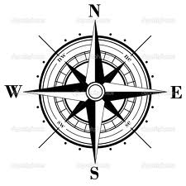
Future Archery Range

BB Gun Range
7
6
5
4
3
2
1
Barn Field Camping Area

Activity Field Camping Area

The Lodge ****
Program Areas
- TBD
- TBD
- TBD
- TBD
- TBD
- TBD
- TBD

Areas or location may change at event
Railroad
T -LODGE *
No Vehicles

Pump House
Fire Bowl
Tyler Creek
Flags
ANSEL Bldg *
Ranger's House
Insert Event Name
CAMP BIG TIMBER Three Fires Council

- Tyrell Road
Big Timber Road
Tree House

PARKING AREA
All Vehicles

Tony's Cabin

