Dial in Option:

Phone Number: 1-646-307-1479

Passcode: 709829

**Join the Webinar! Global Meet Webinar Information**

1. Go to : <https://scoutingorg.globalmeet.com/ThreeFiresCouncil>
2. Decidehow you would like to join the meeting. You can download the Global Meet app; however, it is not necessary. You can join the conference in your web browser by selecting the “Continue in Browser” text shown in the image below.

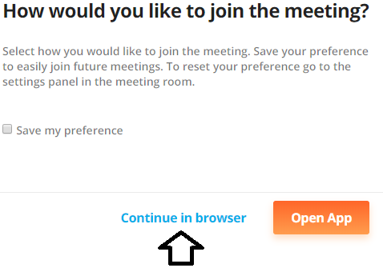

1. Enter our client ID number: 28465824 and select “Continue as a Guest”

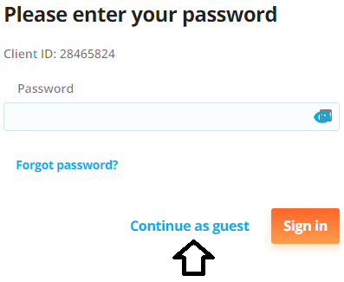

1. Provide your name and email address. This information will let us know who is on the web conference with us.

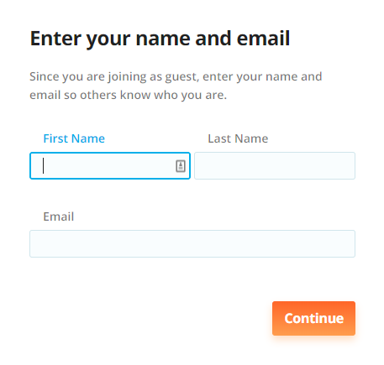

1. Decide how you want to connect to the audio. If you select “Use my computer” it will utilize your computer’s microphone and speakers. You may also select to use a standard phone connection.

